**Definitions:**

* It is object-based, lightweight, cross-platform translated language. It is widely used for client-side validation. The JavaScript Translator (embedded in the browser) is responsible for translating the JavaScript code for the web browser.
* JavaScript also has four built-in objects: Array, Date, Math, and String. Each object has special-purpose properties and methods associated with it. JavaScript also has constructors for Boolean and Number types.
* An anonymous function is a function that has no name. These functions are declared dynamically at runtime using the function operator instead of the function declaration. The function operator is more flexible than a function declaration.
* BOM stands for Browser Object Model. It provides interaction with the browser. The default object of a browser is a window. So, you can call all the functions of the window by specifying the window or directly. The window object provides various properties like document, history, screen, navigator, location, innerHeight, innerWidth,
* An async function is declared with an async keyword. It always returns a promise and if the value returned is not a promise, the JavaScript will automatically wrap the value in a resolved promise.
* The await keyword makes JavaScript wait until the promise returns a result. It works only inside async functions. JavaScript throws Syntax error if await is used inside regular functions. Await keyword pauses only the async function execution and resumes when the Promise is settled.
* The difference between encryption and hashing is that hashing is one way process, meaning if we hash something, we cannot convert it back to its original form, whereas encryption is 2 way process where we can convert encrypted value back to original form

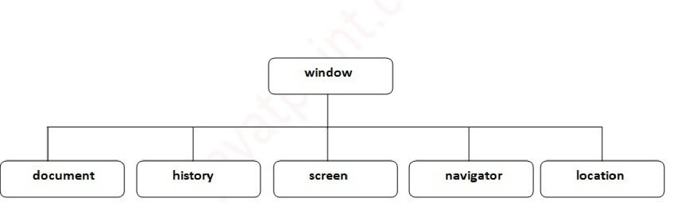

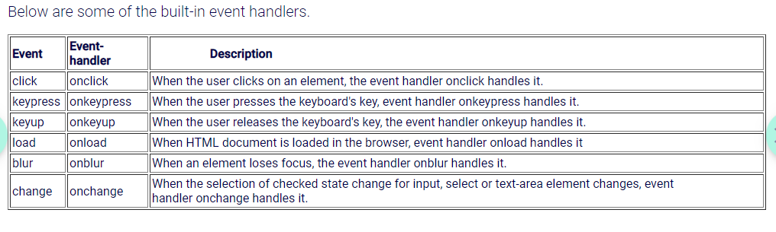

Build in global object for javascript:

* Date
* String
* Math
* RegEx
* JSON

**Async programming:**

* An async function is declared with an async keyword. It always returns a promise and if the value returned is not a promise, the JavaScript will automatically wrap the value in a resolved promise.
* Await keyword makes JavaScript wait until the promise returns a result. It works only inside async functions. JavaScript throws a Syntax error if await is used inside regular functions. Await keyword pauses only the async function execution and resumes when the Promise is settled.

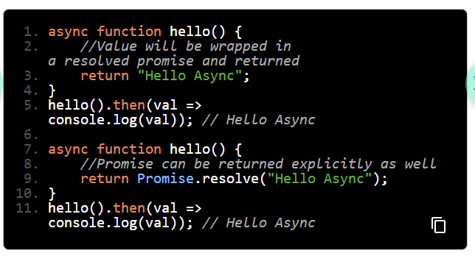

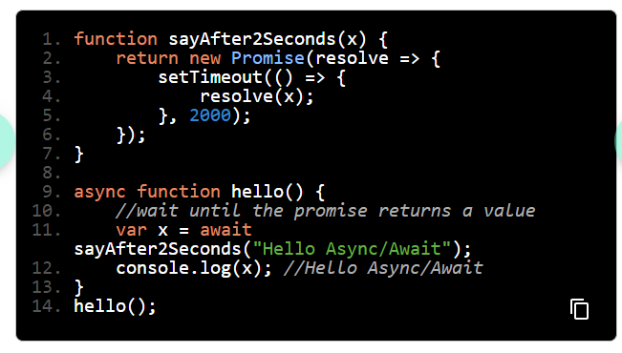

Note - http is stateless protocol

Memoization: Memoization is a technique for speeding up applications by caching the results of expensive function calls and returning them when the same inputs are used again.

**Node.js Course:**

* Node.js is the javascript runtime environment which uses V8 javascript engine
* Node js is a single threaded application with uses asynchronous and non blocking I/O concept to handle http request, it uses libuv library which provides non blocking i/o and it works on threads
* A callback function is a function that is passed as an argument to another function. Callbacks make sure that a certain function does not execute until another function has already finished execution.
* Callback hell, which is also called a Pyramid of Doom, consists of more than one nested callback which makes code hard to read and debug. As calls become more nested, the code becomes deeper and increasingly more difficult to manage, especially if there are more loops, conditional statements, and so on in the code.To overcome the disadvantage of callbacks, the concept of Promises was introduced.
* Before, Node Javascript could not be used as a general purpose programming language; it can only be used in browsers.
* One key difference between require and import is that require can load CommonJS modules, while import can only load ES6 modules. To load CommonJS modules with import, you can use a transpiler like Babel.Another difference is that require is a function, while import is a statement. This means that you can use require in conditional statements, loops, and other control flow structures, while you cannot use import in this way.
* Arrow function does not have this binding and hence is not suitable for methods.
* This is the example why arrow function does not have this binding
* This.name is accessible from its parent method but in case of standard fn it will be undefined
* An SSH key is an access credential for the SSH (secure shell) network protocol. This authenticated and encrypted secure network protocol is used for remote communication between machines on an unsecured open network.
* A promise is essentially an improvement to callbacks that manage all asynchronous data activities.

Node js working:

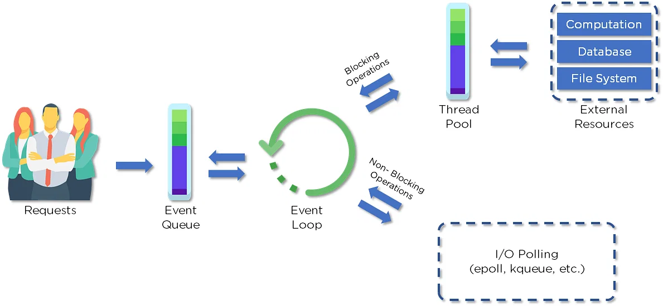

Workflow of async node js code:

main() → node api registered call → callback queue → event loop(starts callback queue once main method completes) → end

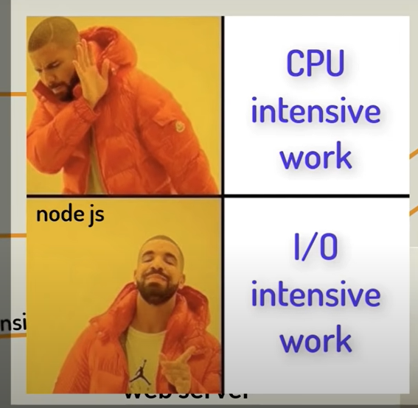

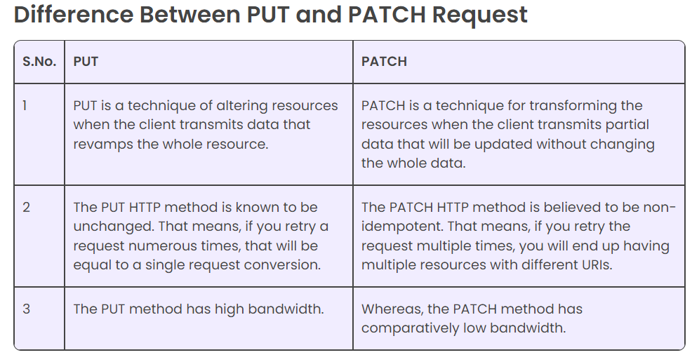

Security basics:



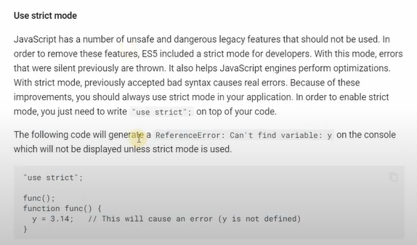

Youtube javascript course: